For this final essay, we're required to provide information concerning our approach to implementing the game of Reef Encounter. This information includes topics such as the reason for choosing the specific implementation, the details involved in designing the game, the functionalities like the original game, and the features added to make the implementation unique from the original.

To begin I understood that to design a fully functional game, with all the information, mechanics and dynamics, it's imperative that a robust and abstract means of design be used. I knew I had to focus on classes and encapsulation if I ever hoped to include all possible details of the game and that these were necessary for saving and loading the game states from the database. So, using php.net, I followed a mediator design pattern to create one super class which other classes were encapsulated into and I named it "page.php", just because it sounded so original. From this super class, I could create a game object which could be passed across multiple pages and modified as necessary based on the current game state.

Next, I decided to use a linear approach to design the game; I started from the beginning and attempted to work my way to the end based on the rules and flow of the game. I first created the intro screen welcoming players to the game as seen below.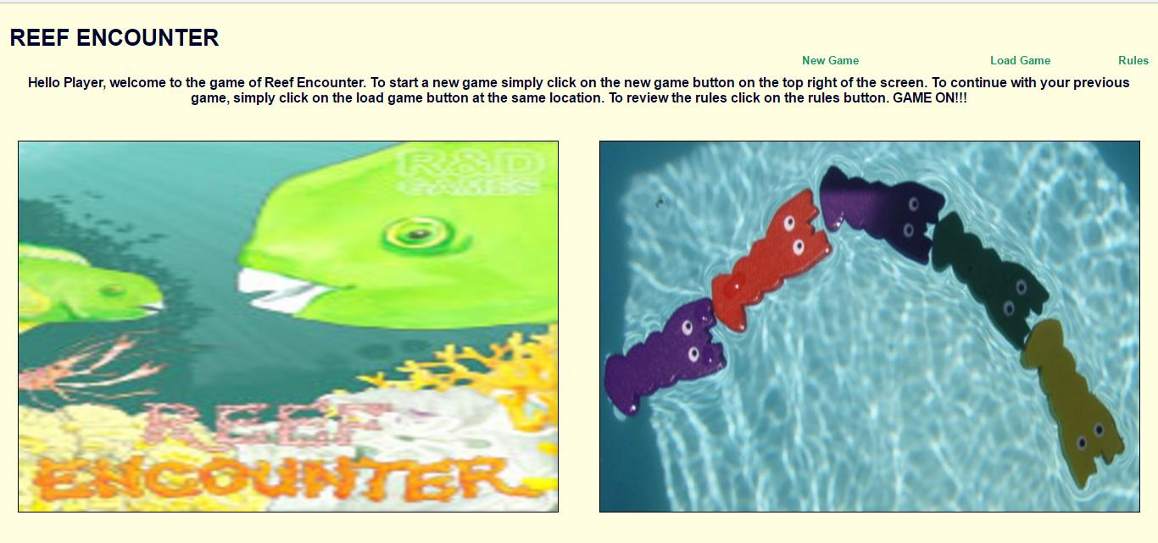

I then implemented a structure in the page class that allowed me to display any links I wanted available to players dynamically, and these are those green links above. Once the player is done choosing to either start a new game or loads a previously saved one they are immediately transferred to another page consistent with their decision. Assuming the player chose to start a new game, they are prompted to choose the number of players they wanted for the game session, and relative to the actual game of Reef Encounter, a corresponding number of boards are created. I made sure everything was dynamic by making use of counters, quotients, and mods to control everything. The board choices are completely random to prevent predictability of gameplay.

One unique implementation from the original game of RE is that players are now given the opportunity to place the initial polyp tiles where they see fit. The goal of this implementation is to increase player freedom to design the game as they see fit. Allowing players this freedom provides them the opportunity to gain an unfair advantage or set up the game board in such a way it's extremely difficult to win. I made sure players had no option but to fill out one board at a time as I wanted to prevent unintended consequences that arise from giving options to players. Below is a screen shot of this page.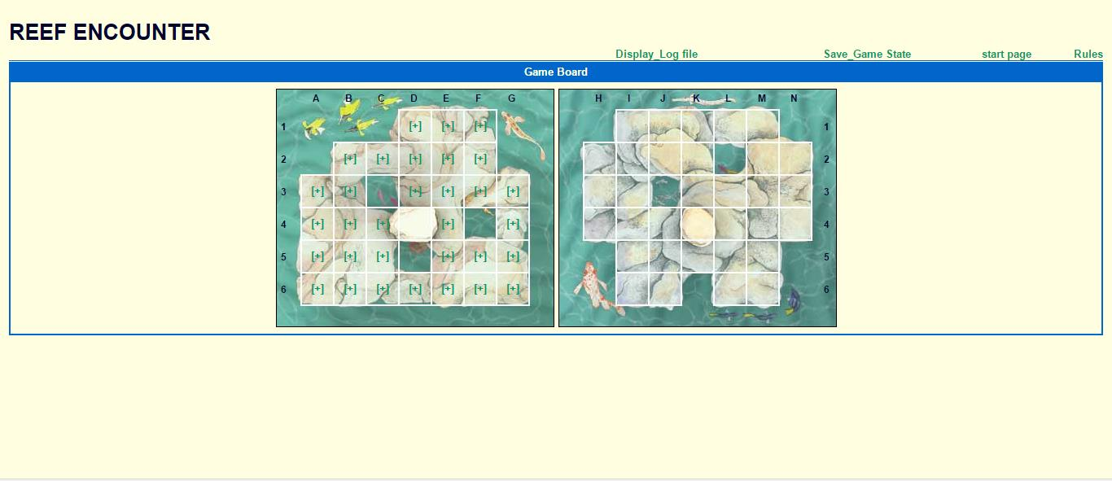

Once players are done setting up predetermined tiles, they are transferred to "configuration.PHP" where they are required to choose polyp to place in their parrot fish and their larva cube. Radio and checkboxes were used for these choices respectively, and even if the player failed to choose, a random choice was made for them. Then, according to the game of RE, polyp tiles are awarded to the player based on who starts first and the distribution is exactly like the original game. Below is a screenshot of what this looks like.

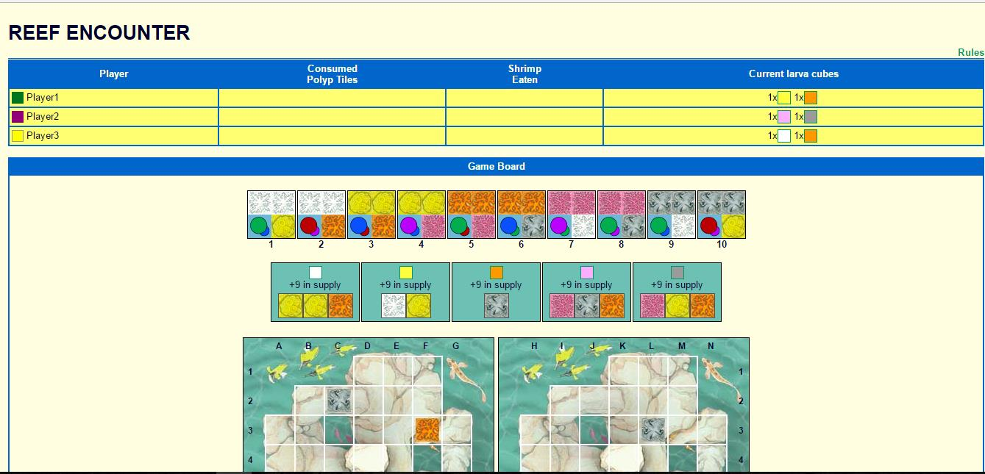

Then the real game begins, the dominance tiles are created by a dominance class, and the open seaboard is created by an OSB class and is distributed randomly in accordance with the game of RE: 3 sizes 3 polyps, 1 size 2, and 1 size one clockwise direction. All these classes are encapsulated in the page class, and with each player's turn, the turn counter increments, thus switching to the next player. I also had everything required to make the game fully functional, maybe even add a scoring system, but I was unable to integrate the game with the action buttons and functionality we'd built earlier due to lack of time and semester workload. However, I did manage to link the group of web pages containing these actions functions to action game thus allowing players to enjoy the full functionality of actions such as placing and moving shrimp, placing polyp tiles and similar actions. Below is a screen shot of this.

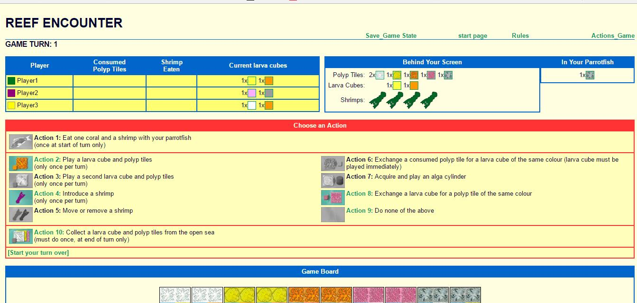

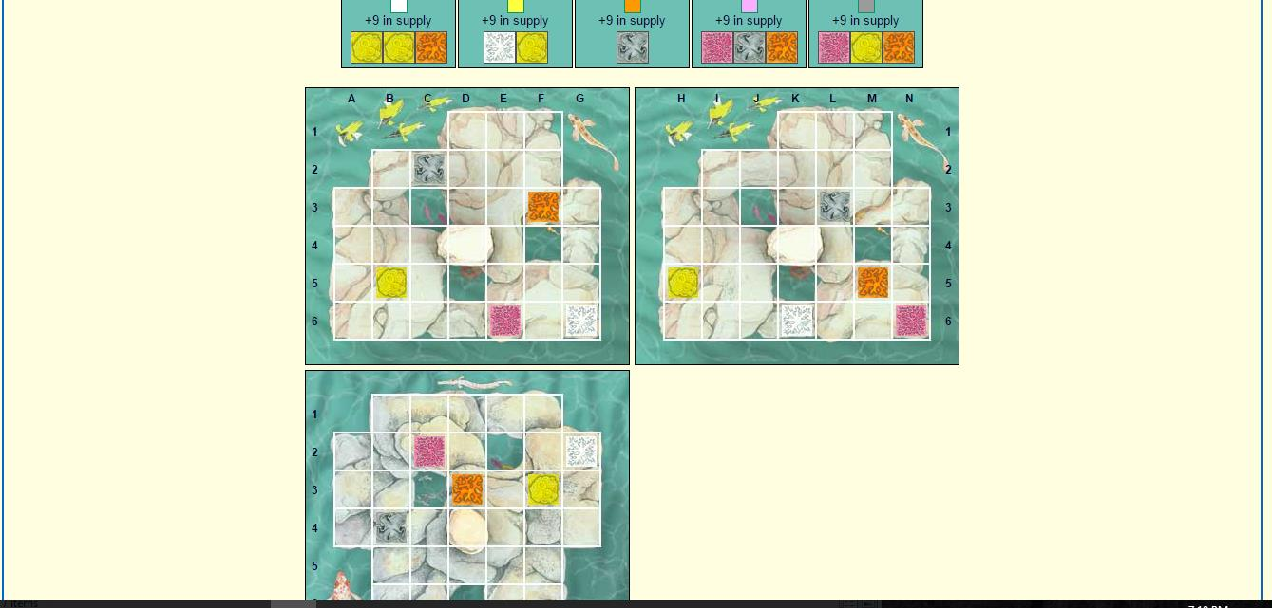

As you can observe, the game is almost fully functional, with some parts missing, and even better is players are able to save their game and resumed at the saved location simply by clicking save game state during the game and load game at the start of the game. This is performed with databases and serializing the game object and storing it in the database and then retrieving it when needed. The remaining description on how the actions and other functionalities are described below in the words of Roman.

Once you begin you will see the heading some text and two images, since my partner implemented all the beginning of this project we will quickly go through it and I will talk about what I accomplished over these few weeks. Once you are on the first page click the new game button. 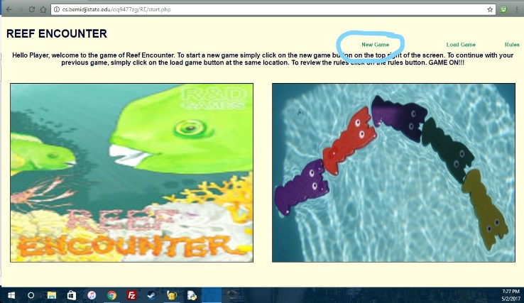

Once you have clicked it you will see three choices of numbers of players to choose from. Feel free to choose any of them. Then you will want to click choice. You can also click the link above if you wanted to go back to the start page for whatever reason. Once you have clicked choice you will see the boards come onto the screen, the number of boards will vary depending on what you chose on the last page.

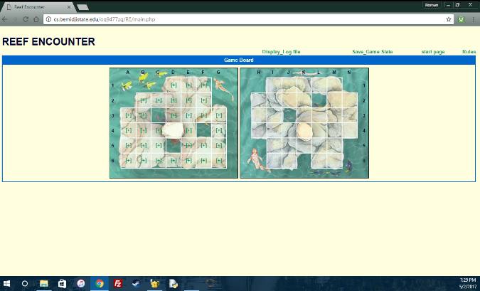

Now you can place the initial polyp tiles on the board. If you are on my reef encounter page (roman’s) then you will get an error on the bottom of the screen, don’t mind that. This part works flawlessly on my partner’s page so refer to his for the beginning pages.

After you’ve placed the last tile click on the large link below that reads “FINISHED WITH TILES”. You will then be transferred to another page, my partner created this page on his own so I’m sure he explains it. 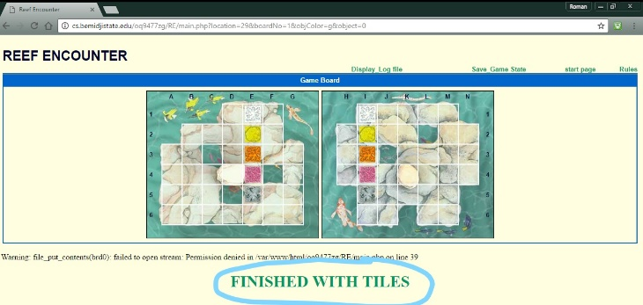

To begin actual gameplay, click the large link below that reads “FINISHED WITH CONFIGURATIONS”.

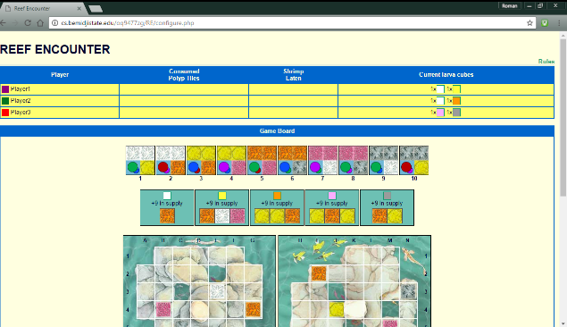

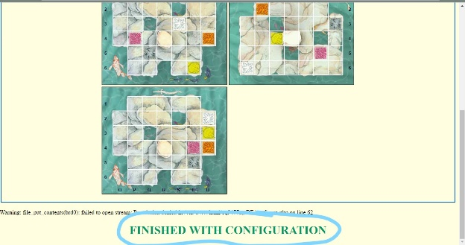

Now in the upper right-hand corner click on Actions_Game. Now we can begin a walk-through of the actions.

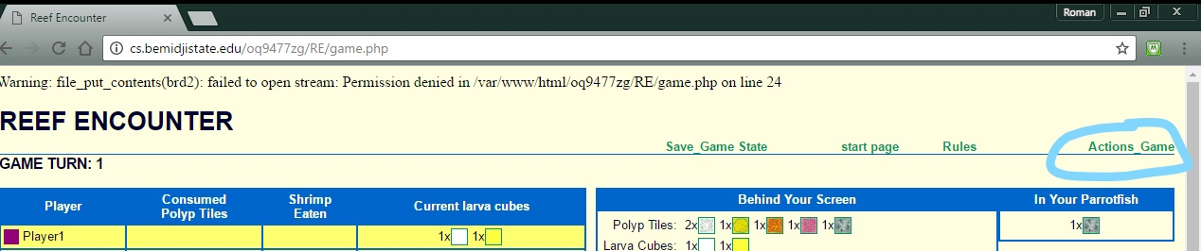

First, you can look at the player info, where it says player, Consumed polypTiles, shrimp eaten and initial larva cubes. That table is all generated through two functions, one for player1 and the other for player2. The functions do the same thing so I will run through one of them. It essentially is a 2-d array that has arrays that contain a letter and a number. There are 5 arrays stored in the player array which displays the initial larva cubes. In each of the 5 arrays, there is a letter and a number. When we look through the array we look at the letter and then the number and that determines what initial larva cubes to display if the number is greater than zero. It also will display the number of shrimp eaten, but we will cover that a little later.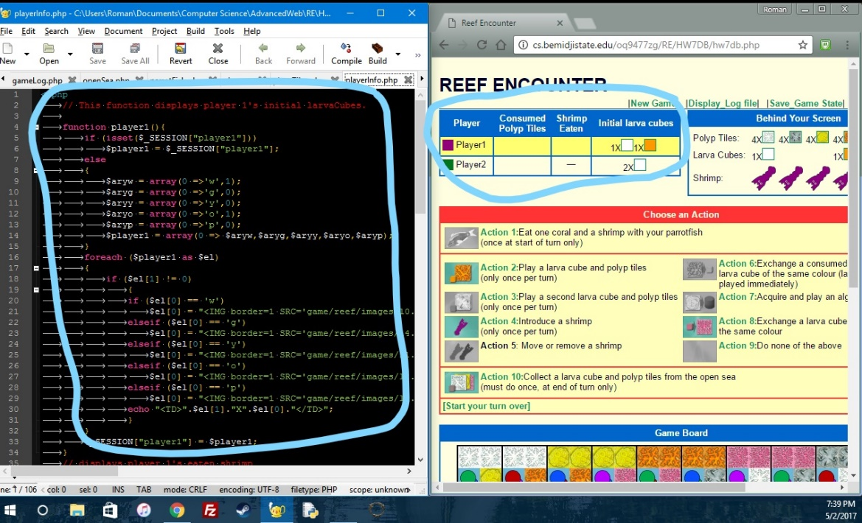

Now looking at the behind your screen section that displays the polyp tiles, larva cubes, and shrimp. The polyp tiles and the larva cubes are set up exactly like the initial larva cubes array, they are 2-d arrays that display the images if the number inside that array is greater than zero. 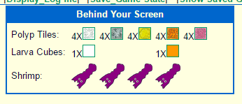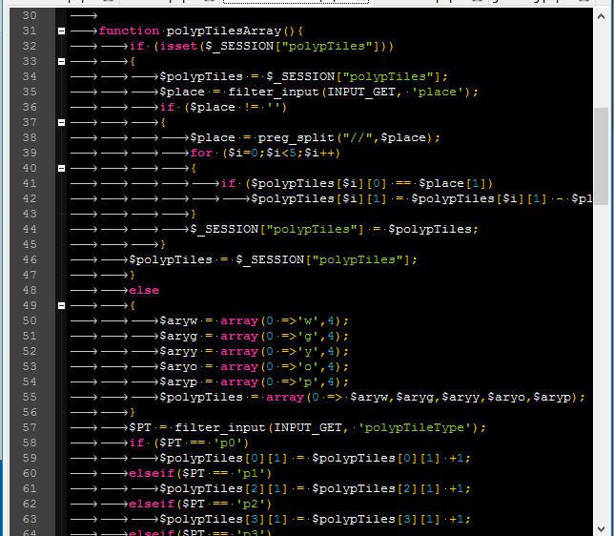 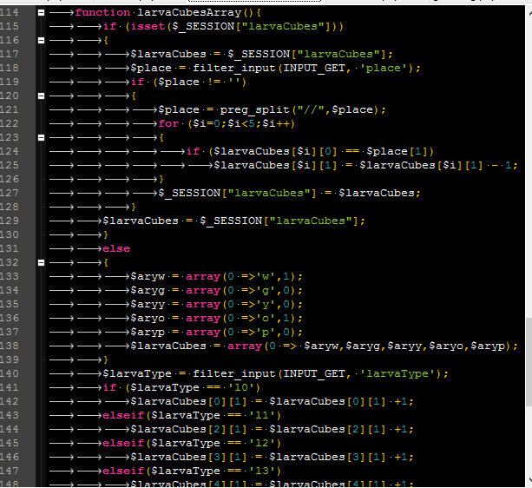

The shrimp are simply in a single array, that contains the string “p” four times. 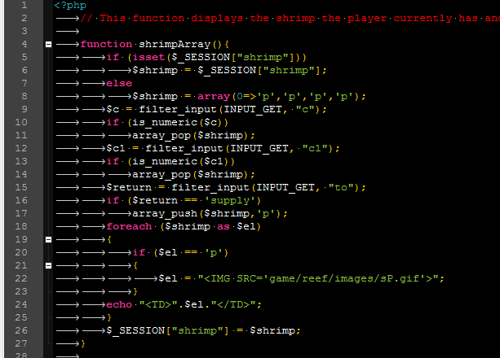

Looking at the in your parrot fish section, the image is also displayed using a 2-d array that contains arrays for each color and the number there are of each. 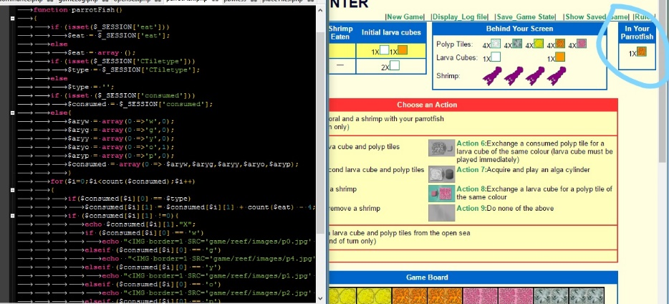

When looking further on into the Choose an Action section, all the actions are displayed through functions. Each action is displayed through its own function. The reason for this is so once an action is completed it will then be disabled conditionally. Like action 1,2,3,4, and 10 once completed are switched off because you can only do it once per turn while action 5 can be completed any number of times. Action 8, however, has its own condition and only turns off once you run out of larva cubes. I have completed Actions 1,2,3,4,5,8, 10, and a simple version of Action 7. We will go through the actions in a little bit.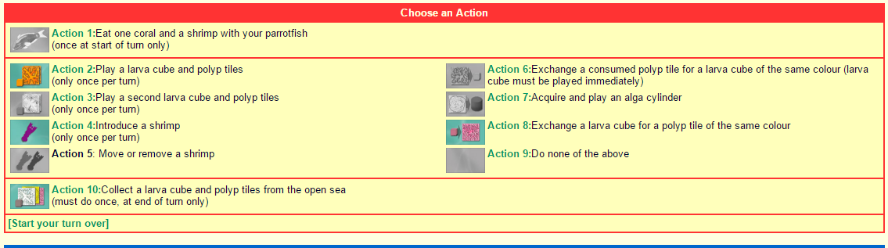

The Game board section is also all created through PHP.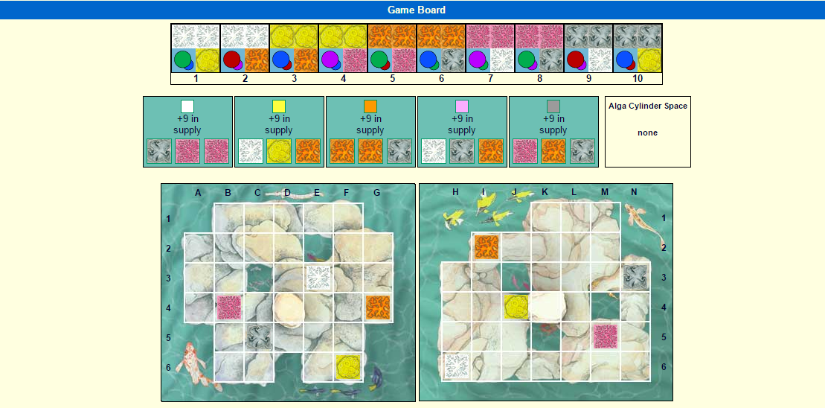

I will start with the dominance tiles; all images are displayed through a 2-d array. There are 10 arrays inside of the one dominance array, all of which contain 2 numbers and a string. 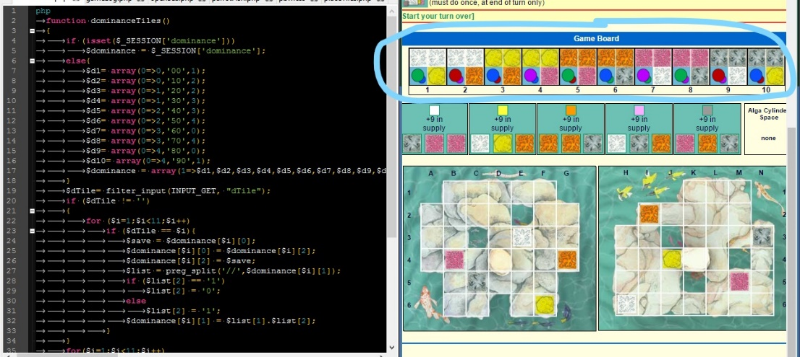

The first number is used to display the dominating tiles for example when looking at the first square. The two white tiles are displayed using the first number which is a 0 it is then appended to a string which defines the image to echo out. The next item in the array is a string. This string is used to display the dominance switching image. I have made this image a link that switches the dominance, this is the early stages of action 7. Then the last item in the array is another number which displays the bottom image, the polyp tile that is dominated. When you click the image link a few things happen. The image link changes, it switches, for example in square 1 the green oval is in front and the blue oval is on the back.When clicked, it reverses, the blue oval is upfront and the green image is in the back. Also, when clicked the dominance switches so, if looking at the first square you will see once clicked the yellow will dominate over the white.

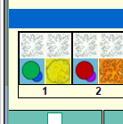 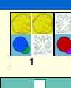

You can also click the image again to change it back to its original state. This works for all the 10 dominance tiles, feel free to click and switch dominance. As of right now, the dominance has no meaning, I never got to implementing the actual meaning, that is why it is only the early stage of action 7.

Now moving on to the open seaboard. This is another 2-d array that contains 5 other arrays. Each array contains 5 items. The first displays the larva cube, one for each color. The next three items show the polyp tiles. At the start of the game, these polyp tiles are all generated at random. Then the last item in the array is a number which displays how many of the larva cubes are in supply. 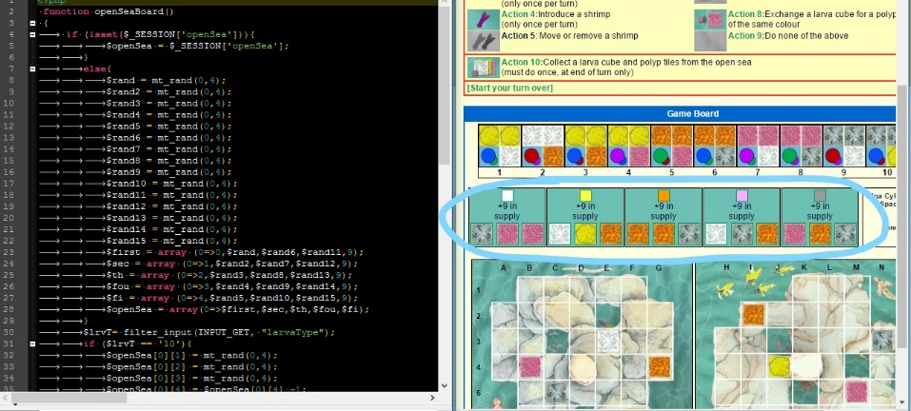

Moving onto the game boards, we had some minor changes recently that might've changed this but it was working at one time so I apologize if it is not correct. Anyway, the game boards should be the first two game boards displayed when initially placing the polyp tiles before the start of the game. Also, the polyp tiles should be in the same place as chosen when you placed them, if not I apologize, our recent changes might've messed that up. Will try to fix it before you look at it.

We have now covered the basic layout of the page. Every function so far is not displayed directly on our main page. We implemented each function in its own file so that we would not have a huge mess of code on one page. We use an include in the page to call the functions from whichever file it is in when we need it and where we need it. 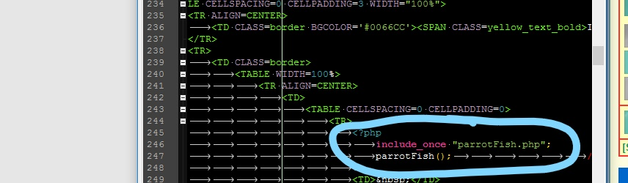

The initial look of everything is all stored in a session, that is how everything stays the throughout refreshes of the page and gameplay. If at this point you click save_game state at the top of the screen it will save the state of the boards in a database. To view what was save simply click on the show saved game link which is also at the top of the screen. 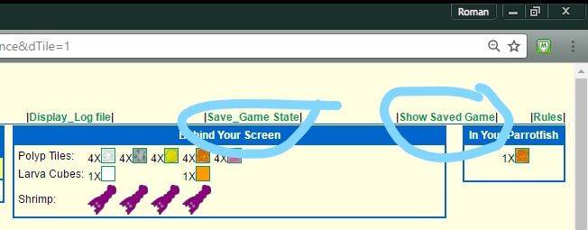

This grab what's in the database and displays it neatly in a viewer friendly table. You will see that there is a table for the shrimp and the boards. To get out of this simply click your browser's back arrow to return to the game.

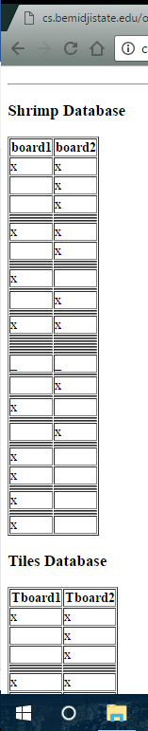 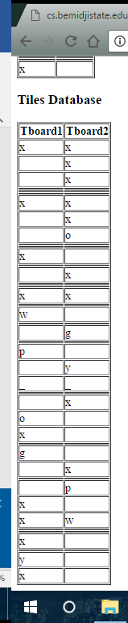

Feel free at any time of the game to save and check that the database indeed updates and saves the current game state. We did not yet implement saving all the other player information such as inventory and what’s in the parrotfish. That would be essential for being able to save and load your games. As of right now this is a one player game and is a run through of the actions. I will now begin going through each action one at a time and explaining all the changes that happen and how it is done.

We will start with action 2. Since action 2 and 3 are the same I will only go over action 2 but feel free to do action 3 at any time, just follow the same instructions. When you click on action 2 you will notice that larva cubes are displayed with checkboxes next to them. They are only displayed if there is at least one larva cube and one polyp tile of the same color. Now click in one of the checkboxes and click the choose larva button.

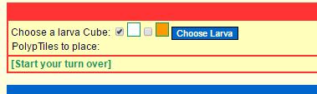

You will now notice a drop down that you can choose the number of tiles to place, so go ahead and choose (I will ask that you choose the maximum number of tiles for this one). Once your desired amount is chosen click the amount of polypTiles button 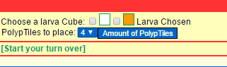

Then click the place Tile link that took its place. You can now see both boards have targets displayed in all valid places a tile can be placed. You can now place the tiles anywhere you wish. I’m going to ask for action 2 that you place them adjacent to one another and connected to the corresponding colored tile on the board so that action 1 can be implemented to its fullest potential.

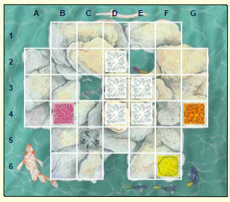

When doing action 3 however you can place the tiles wherever you desire and as many you would like. Now that action 2 is complete if you look at the behind your screen section you will notice that the larva cube and a number of polyp tiles you chose have vanished. That is the point because they were used and placed on the board. Also, you will notice action 2 is disabled you can no longer click it. Now I will have you complete action 3. Action 3 should now be disabled and the larva cube and polyp tiles should be gone from behind your screen.

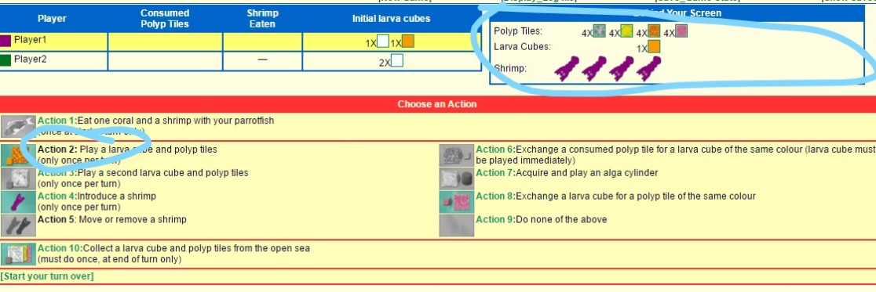

Once action 3 is completed we will move on to action 4. Once action 4 is clicked you will see that targets appear on all valid locations to place a shrimp.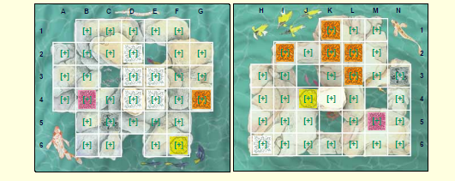

Feel free to place a shrimp anywhere you would like. Once you have clicked one of the targets you will notice that the shrimp is on the board and that one shrimp has disappeared from the shrimp array in behind your screen.

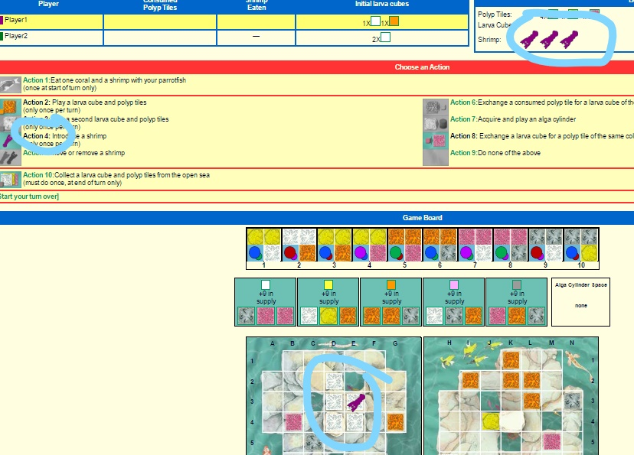

If you want to, now would be a good time to save the game state and view it. You can also click the display log file to see what has been done. We have the basic functionality of this working but there are a few bugs. But you can see the moves that have happened like tile placement, actions clicked, and shrimp placement. This is also saved into a database when the save game state link is clicked so that you can see what has been done in the past. Now click the return to game link.

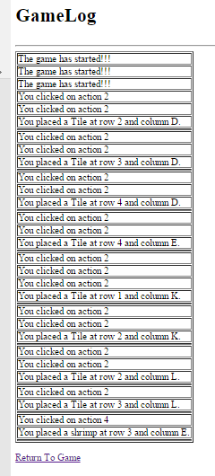

For the implementation of action 5 we will be placing the shrimp on the coral that we produced in action 2 if not already on it (This is essential so that we can implement action 1 to its fullest potential SEE PICTURE BELOW.). When you click action 5 you will see a bunch of targets again, click on the shrimp, you will place the shrimp on the biggest coral (created in action 2). 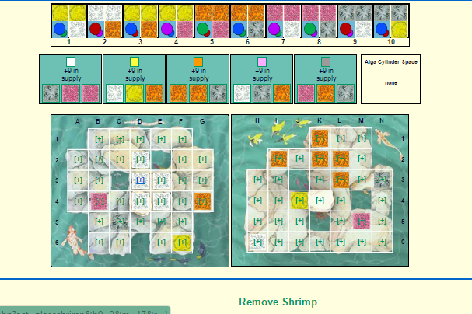

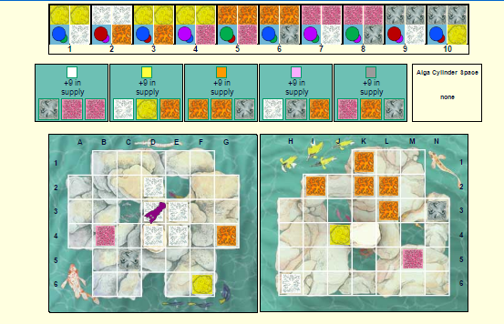

There is a remove shrimp link below, for this demonstration I will ask that you do not click it. Now that the shrimp is moved onto the biggest coral, you can click on action 1.

When action 1 is clicked, the shrimp image becomes a link. Click on the shrimp. Then you will see a huge link on the bottom of the screen that reads “FINISH ACTION 1”, click it.

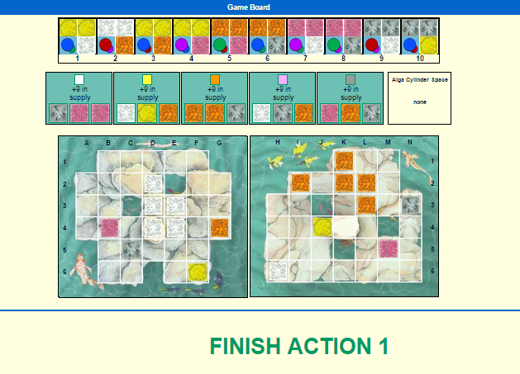

Now a few things happened after that click. You will see that in the player info it displays a 1 in the shrimp eaten by player 1. Depending on if you ate white or orange tiles you will see that in your parrotfish has updated. If you placed white tiles and the maximum amount, your coral should've been 5 tiles altogether. This means that you should now have 1 white tile in your parrotfish. Due to the rules, the parrot fish is a messy eater so you discard four tiles from the coral and the remaining number is placed in you parrot fish which in this case is one. If you chose to place orange tiles, then you should now have a 2X in your parrotfish for orange.

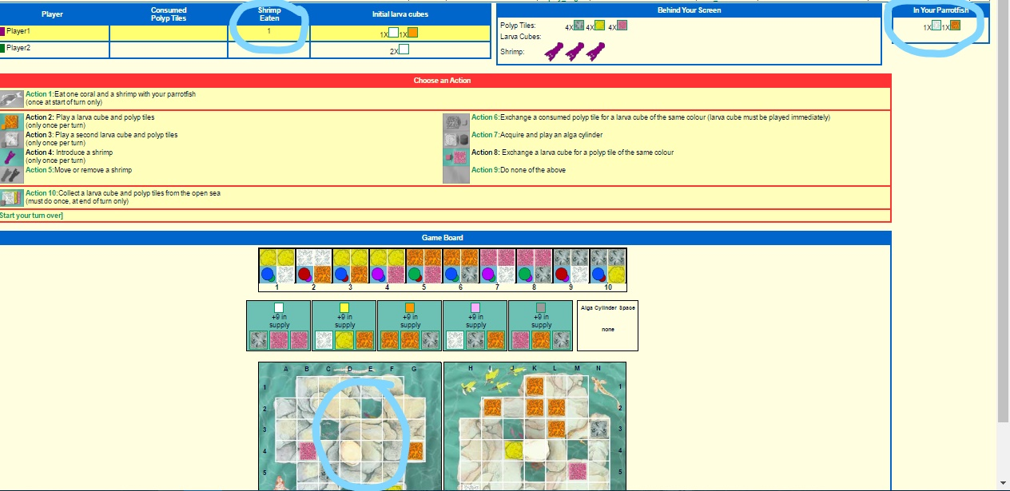

We will now move on to action 10. Once action 10 is clicked the open seaboard will take the place of all the actions. You can now click on the larva cube in one of the boards provided.

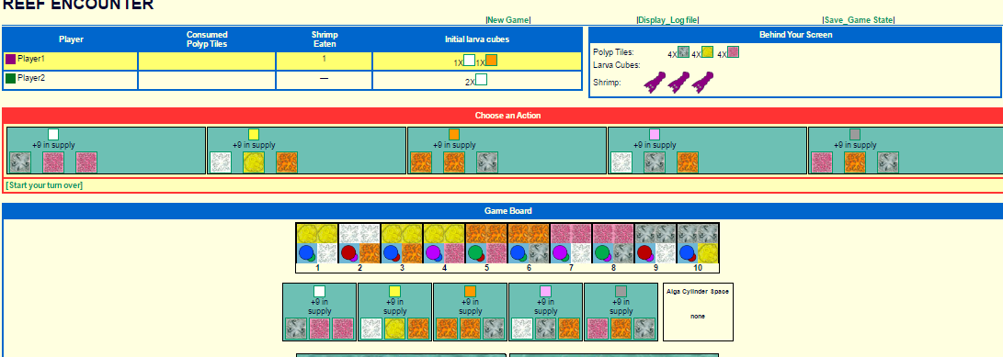

When clicked, you will notice that the larva cube and all the polyp tiles that were displayed on that board added to your inventory. You will also notice that the board you clicked on the number which displays the supply has decremented. So, if it was at 9 it will now be at 8 and so on. You will also notice that inside that board only the polyp tiles have been changed and displayed randomly again.

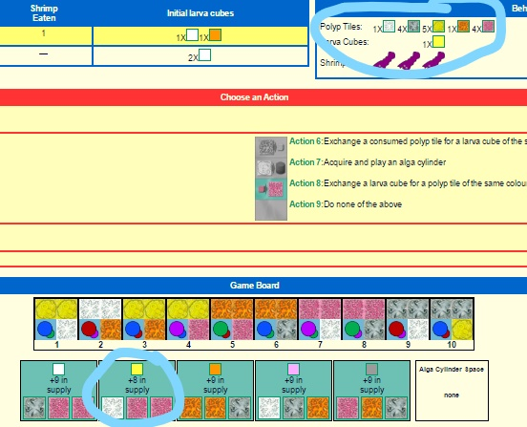

I guess now that you have some added larva cubes you can go onto clicking action 8. When clicking action 8 it will display all larva cubes that you can exchange for a polyp tile of the same color.

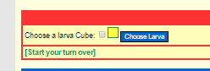

Go ahead and choose one then click the choose larva button, then the done link.

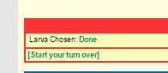

You will see that you have lost that larva cube but have gained a tile of the same color. If you repeat that process until you run out of larva cubes you will notice that action 8 will disable.

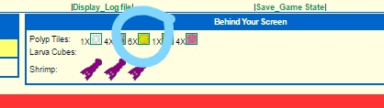

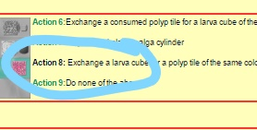

You have now reached the end of the walkthrough. Over the past few weeks, I have done my best to implement as much as possible, but there are still lots needed to be done. A lot of the rules are not in play and some of the actions may not work exactly right. This project, however, helped me learn and gain knowledge on web development that I will go on using in future assignments. I hope this was enough for the time allowed to work on it.